**Philips uApp Template**

**Installation document:**

**Prerequisites:** xcode command line tools should be installed and should point to xcode path

*If command line tools are not available*

xcode-select --install

sudo xcode-select –switch /path to xcode

***Installation and Creation of New Micro App:***

1> Go to Terminal and go to the Template Folder and run the below Command:

sudo bash Philips_uApp_Template.sh

2> After installation success,quit Xcode.

3> Open XCode

4> Go to: File->New->Project

5> You can see “Philips uApp”

6> Select “Philips uApp”

7> Write the micro app name in Product Name

8> Select Language (Objective C/Swift)

9> Select Next

10> Choose save location

11> This will create a Framework Project of the new uApp

12> Open Project via Xcode

You can see folder structured micro app in Xcode and in Finder.

**Philips uApp Template in Xcode:-**

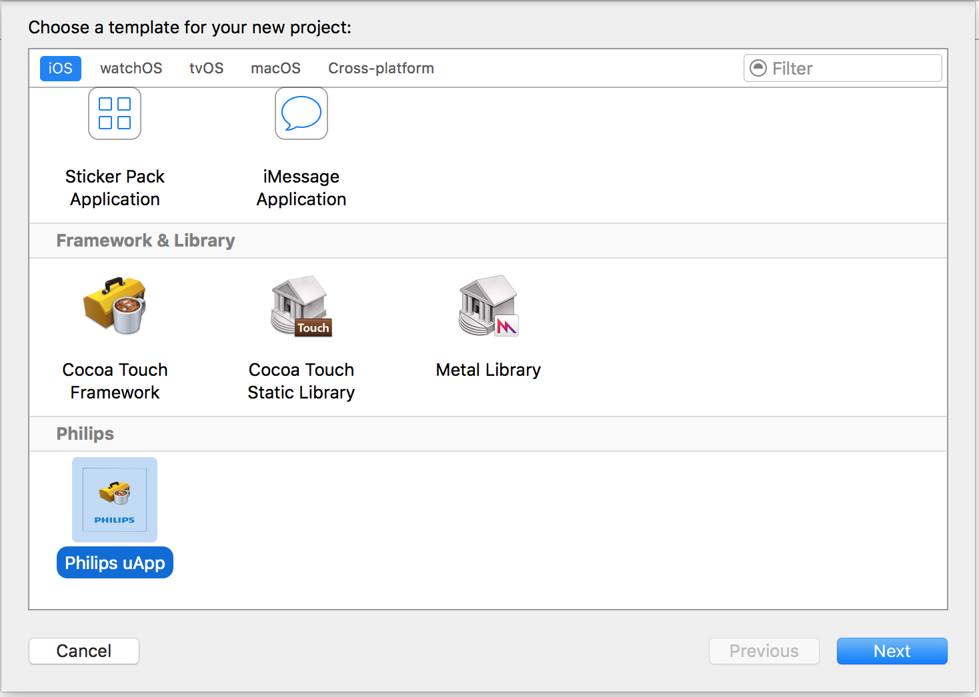

**New Philips uAPP Folder Structure created using Philips uApp Template:-**

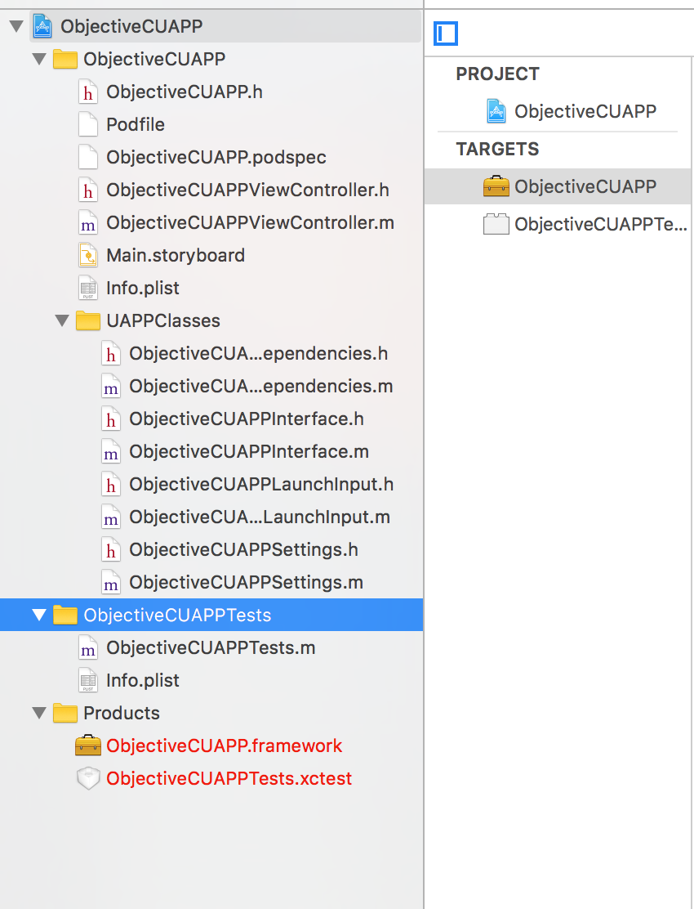

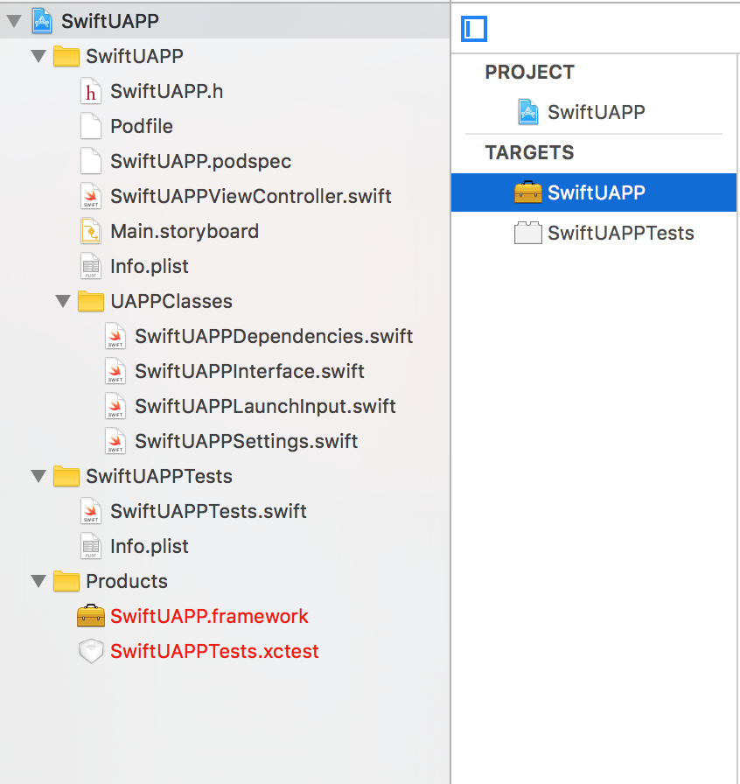

**Files automatically generated by Template:-**

1. **<PROJECTNAME>Dependencies** -> This will be subclass of UAPPDependencies and all the dependencies for the UAPP should be added in this class.
2. **<PROJECTNAME>Interface** -> This will be subclass of UAPPInterface and the UAPP Initialisation and launching should be done in this class.
3. **<PROJECTNAME>LaunchInput** -> This will be subclass of UAPPLaunchInput and should contain all Launch Inputs needed for the UAPP.
4. **<PROJECTNAME>Settings** -> This will be subclass of UAPPSettings and should contain all Settings objects which is needed for the UAPP Initialisation.
5. **<PROJECTNAME>.podspec** -> Podspec template for UAPP.
6. **Podfile** -> Podfile template for UAPP.
7. **<PROJECTNAME>.h** (Framework Header File) -> Header file for UAPP Framework.
8. **<PROJECTNAME>ViewController** -> Dummy View Controller.
9. **Main.storyboard** -> Dummy Storyboard.

**Notes:-**

1. This Template will create a micro App which contains the below Components :-
   1. Structured uApp Classes.
   2. Unit Test Class if Create Unit Test is selected at time of Project creation.
   3. Sample View Controller and Storyboard will be created and placed in Root Folder.
   4. Pod file with required dependency added and placed in Root Folder.
   5. Podspec file with required dependency added and placed in Root Folder.
   6. Podfile and Podspec file will be added as part of the project. If one wants,they can remove reference to those files,so that they cannot see the files as part of their projects.